Press Release. Prague, December 14, 2017
Czech Film Center entered into partnership
with Les Arcs festival and coproduction market

The partnership with Les Arcs European Film Festival in France (December 16-23, 2017) is
a part of longstanding activities of the Czech Film Center through which it presents the Czech Republic as an appealing partner in the area of international coproductions. Another goal of the partnership is to support participation of Czech professionals – producers with experience in minority coproductions – and increasing cooperation in European coproduction.

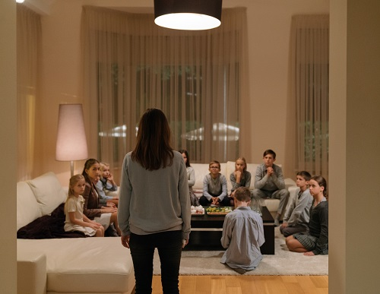
The debut feature of Michal Hogenauer in Works in Progress
This year‘s edition of Works in Progress presents the forthcoming Czech film Outside among the selected 15 projects. The film in development is a feature debut of Michal Hogenauer whose student film Tambylles (2012) premiered in the prestigious Cinéfondation section at Cannes Film Festival. The feature film has won support from the Czech Film Fund as well as Eurimages. The film is a coproduction between Czechia (Negativ Film Productions), Latvia (Aija Berzina – Tasse Films), and the Netherlands (Stienette Bosklopper, Lisette Kelder – Circe Films).
Synopsis:
Mia (23) arrives abroad to work as an au pair for a well-off family living in a lavish villa and is accepted into the upper class. Mia has to look after the seemingly autistic Sebastian (10). At one social event she attends with the family, Mia accidentally witnesses one of the adults beating a little boy with a thin wooden cane while the boy remains silent and controlled.
The next day, the strange memory feels like a dream and her main concern is building
a relationship with Sebastian. But one day she is told that if she wants to stay, she, too, must physically punish Sebastian to show her love for him.

Czech producers at Les Arcs
The partnership with the festival will bolster involvement of the Czech Republic in production of quality and potentially successful European films and will aid Czech professionals in creating close collaborations in this area. The Czech Film Center selected four producers with experience in minority coproductions to participate in the festival and take part in the program of the coproduction market. Attending are Jiří Konečný, whose projects for instance include films Aferim!, Little Harbour, Nina, Out, and Zero; Julietta Sichel (The Chronicles of Melanie, Ministry of Love, and the nearly finished The Cellar); Jordi Niubó (Honey Night, An Ordinary Man); and Radovan Síbrt (Cinema, Mon Amour). Many of them are also currently preparing or finalizing other coproduction films.

Press contact:
Hedvika Petrželková
Czech Film Center/ Czech Film Fund
Národní 28, 110 00 Praha 1
+420 770 127 726
hedvika@filmcenter.cz
www.filmcenter.cz; facebook

