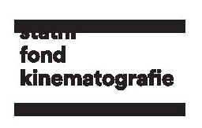
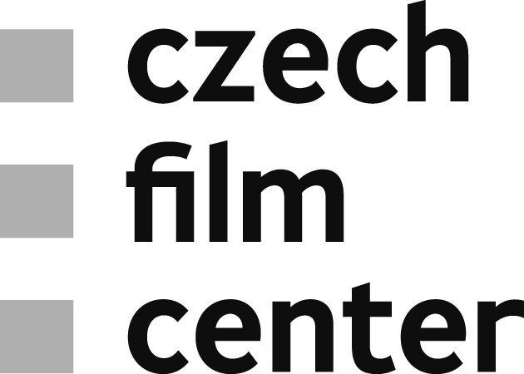
Plzeň | April 15, 2019
Czech Film Springboard at Finále Plzeň 2019
An industry event Czech Film Springboard, organized by the Czech Film Fund / Czech Film Center, was held at the Finále Plzeň film festival between April 13–15, 2019. For the fourth time, promising Czech projects in early development offered an inside look at which way Czech cinema is heading.
During closed presentation and consultation, Pitching & Round Tables, producers and directors of upcoming Czech films in development pitched their projects to invited international experts from various areas of film industry. Later, authors and experts discussed selected projects individually at round tables.
An informal meeting between producers, directors and invited foreign film industry experts was held during Who Is Who. Representatives of co-production markets, financing platforms, festivals, training initiatives and sales agents presented their activities to all film professionals present at the festival.
During a moderated discussion about funding opportunities and co-producing in Europe, Funding News, the representatives of different national funds gave an overview, and answered questions on accessing financing in their countries.
Find out more info about Czech Film Springboard and selected projects HERE.
Press service:
Jaroslav Kejzlar
Editor & Communication
Czech Film Center / Czech Film Fund
_________________________
Národní 28, 110 00 Praha 1
telefon: +420 601 326 883
e-mail: jaroslav@filmcenter.cz
www.filmcenter.cz
facebook

