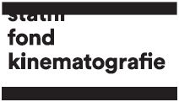
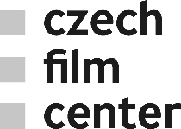

Czech films at Cannes 2019
At the 72th Cannes International Film Festival, Czech-French-Argentinian-Austrian co-production documentary Solo, digitally restored Loves of a Blonde, a Czech-French documentary Forman vs. Forman and a student film One Hundred and Twenty-eight Thousand will be screened during or as part of this year’s official programme.
Solo, a documentary debut of the director and producer Artemio Benki (Artcam Films), will have its world premiere in the ACID. After last year’s screening of The Firemen’s Ball at Cinema de la Plage, another of Miloš Forman’s early films, and an important representative of the Czechoslovak New Wave, Loves of a Blonde will be presented in Cannes Classics. Ondřej Erban’s short student film One Hundred and Twenty-eight Thousand has been selected for the Cinéfondation section.
Solo (Sólo) | ACID
Czech-French-Argentinian-Austrian co-production documentary tells a story about a young Argentinian piano virtuoso and composer, who has been since his breakdown a patient in the largest psychiatric hospital in Latin America. Martin P., the most promising talent of his generation, is now trying to find a way how to overcome his mental disease and come back on the concert stages.
The documentary was supported by the Czech Film Fund with the amount of EUR 58 824. Another financial support was provided by the Creative Europe MEDIA, Eurimages, the Centre national du cinéma et de l’image animée (CNC), INCAA Instituto Nacional de Cine y Artes Audiovisuales, Bundeskanzleramt and Kunst und Kultur (Austria). The main producers are Artemio Benki (also the director of the film) and Petra Oplatková from Prague-based production company Artcam Films.
The last Czech film in the ACID was Petr Václav’s The Way Out, in 2014.
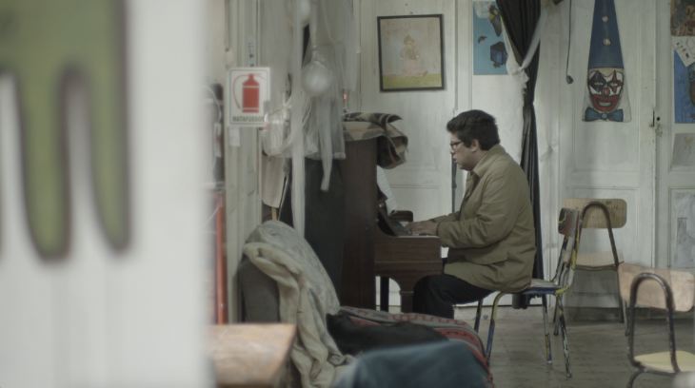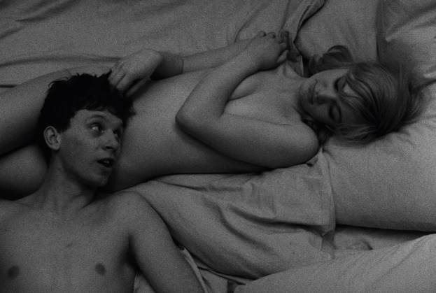
Loves of a Blonde (Lásky jedné plavovlásky) | Cannes Classics
Loves of a Blonde is one of Miloš Forman’s three contributions to the Czechoslovak New Wave. In
a tragicomic story, Forman follows a young woman, Andula, who has a routine job in a shoe factory in a provincial town somewhere in Czechoslovakia, and her attempts at forging a romantic relationship.
In 1965, Loves of a Blonde premiered at Venice IFF, then followed by an Oscar nomination for best foreign-language film, and recently, the film was digitally restored by the Czech National Film Archive.
This marks the third time a Czech classic has appeared in the prestigious section, Cannes Classics, in recent years, following Diamonds of the Night, in 2018, and Ikarie XB 1, in 2016.
Forman vs. Forman | Cannes Classics
Milos Forman the artist. Milos Forman the man. A filmmaker decorated with Oscars for Amadeus and One Flew Over the Cuckoo’s Nest. At the same time a charismatic adventurer with the courage to question himself. The Forman vs. Forman documentary summarizes the life of the most famous Czech film director whose protagonists have always fought against institutions for freedom. The film is a collage of rare archive footage and autobiographic memories narrated by the director‛s son Petr Forman. The documentary is directed by celebrated author Helena Třeštíková and Jakub Hejna.
Kateřina Černá, Dan Vadocký (Negativ), Alena Müllerová (Czech Television), Madeleine Avramoussis (ARTE) and Christine Camdessus (Alegria) were involved in the production of the film, which was supported by the Czech Film Fund with EUR 17 647.
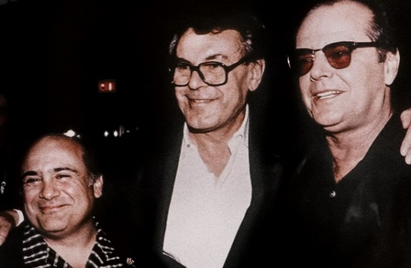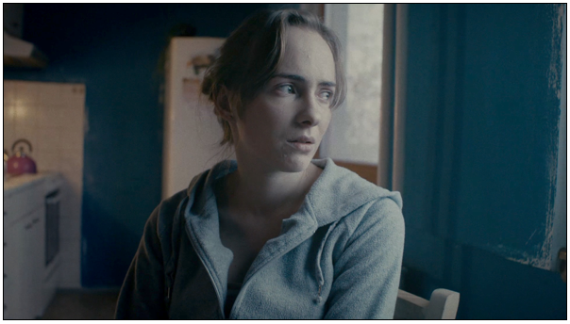
One Hundred and Twenty-eight Thousand (Sto dvacet osm tisíc) | Cinéfondation
Ondřej Erban’s (FAMU) One hundred and twenty-eight thousand focuses on debt and its impact on people’s everyday lives. A winner of the best student film at Czech Lions 2018, is selected in the category for student films Cinéfondation, which supports the up and coming generation of filmmakers.
Czech Films have a rich tradition of participation in the Cinéfondation section at Cannes, the most recent example being Atlantis, 2003, by director Michal Blaško, whose feature-length debut project, Victim, appears this year in the Cinéfondation’s Atelier 2019.
Czech & Slovak Pavilion
The Czech Film Fund and its division the Czech Film Center will as usual represent Czech cinema and film industry at the Czech & Slovak Pavilion No. 130 at Marché du Film.
Doc Alliance Selection Award
Czech Documentary Kiruna – A Brand New World, directed by Greta Stocklassa and produced by Veronika Kührová and Michal Kráčmer (Analog Vision), is nominated by Jihlava IDFF for the Doc Alliance Selection Award.
Press service:
Jaroslav Kejzlar
Editor & Communication
Czech Film Center / Czech Film Fund
_________________________
Národní 28, 110 00 Praha 1
telefon: +420 601 326 883
e-mail: jaroslav@filmcenter.cz
www.filmcenter.cz
facebook

