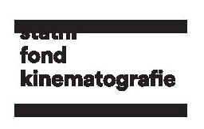
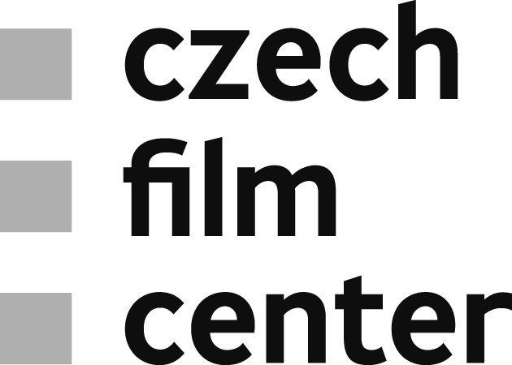

Czech Film Fund awarded €82,353 for Production of Documentaries and
Development of Fiction Features
The Czech Film Fund announced support for the production of documentaries and development of feature-length fiction projects in its recent schemes announced at the end of July. All together 23 projects will be granted the amount of 21 million Czech crowns (€82,353).
The Fund has allocated 12 million Czech crowns (€470,588) for the documentary film production. The highest amount of 2,000,000 CZK (€78,431) went to the production of endorfilm – Každá minuta života / Every Single Minute. The film, directed by Erika Hníková, depicts a modern-day family that decides to raise their children following the unorthodox educational method „kamevéda“. The second highest amount of 1,500,000 CZK (€58,824) was granted to a documentary directed by Vít Klusák and Barbora Chalupová that deals with the topic of bullying V síti (production of HYPERMARKET FILM). Finally, 1,300,000 CZK (€50,980) went to a biopic about an exceptional man and songwriter Šifry Jana Kapra / Jan Kapr’s Ciphers (directed by Lucie Králová and produced by DOCUfilm Praha).
Further supported projects:
Můj otec Antonín Kratochvíl / My Father Antonín Kratochvíl (dir. Andrea Sedláčková, produced by Punk film) – 1,200,000 CZK (€47,059)
Pongo story (dir. Tomáš Kratochvíl, produced by Produkce Radim Procházka) – 1,200,000 CZK (€47,059)
Ve jménu Alláha / Brotherhood (dir. Francesco Montagner, produced by nutprodukce) – 1,000,000 CZK (€39,216)
Vlci na hranicích! / Wolves on the Borders (dir. Martin Páv, produced by Frame Films) – 1,000,000 CZK (€39,216)
Epocha mezi srpnem a listopadem (dir. Jan Rousek, produced by GPO Platform) – 800,000 CZK (€31,372)
Legenda Suchý (dir. Olga Sommerová, produced by CINEART TV Prague) – 800,000 CZK (€31,372)
Mucha (dir. Roman Vávra, produced by Punk film) – 600,000 CZK (€23,529)
Nová šichta / The New Shift (dir. Jindřich Andrš, produced by moloko film) – 600,000 CZK (€23,529)

Within the development of fiction features scheme the amount of 9 million Czech crowns (€352,941) was distributed among twelve projects. Also here, endorfilm scored the highest award of 1,400,000 CZK (€54,902) with its production Můj praděda – pirát that takes on the best tradition of adventure films for children. The second highest project evaluation of 1,200,000 CZK (€30,600) went to a visually and conceptually unique auteur film Binderiana, a production of Marina Films. Produkce Radim Procházka and its film Černé slunce that takes inspiration from the tradition of 1970s Czech sci-fi received the third highest award of 800,000 CZK (€31,372).
Further supported projects:
Jeho slovo, její slovo / His Word, Her Word (produced by love.Frame) – 750,000 CZK (€29,412)
Už tě nemám rád (produced by i/o post) – 720,000 CZK (€28,235)
Krvavá nevěsta (produced by Snake Catcher) – 700,000 CZK (€27,451)
Město bez Boha (produced by 8Heads Productions) – 700,000 CZK (€27,451)
Světlonoc (produced by moloko film) – 700,000 CZK (€27,451)
Rok vdovy / Year of the Widow (produced by ARTCAM FILMS) – 699,000 CZK (€27,412)
Nehybnost (produced by CINEART TV Prague) – 680,000 CZK (€26,667)
Fichtelberg (produced by CINEART TV Prague) – 650,000 CZK (€25,490)
Oběť (produced by nutprodukce) – 1,000 CZK (€39,2)

