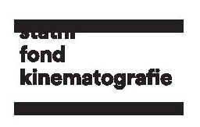
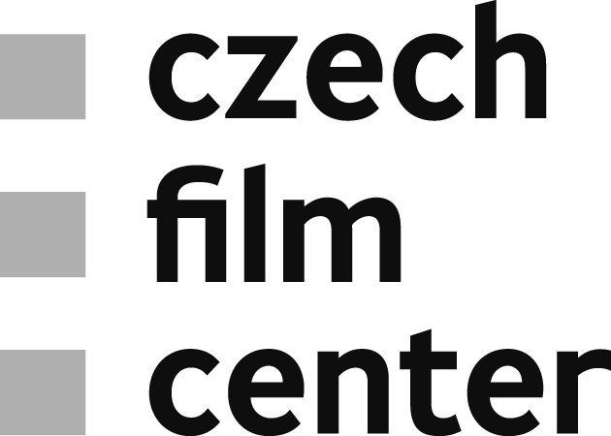

Main Awards for Czech Films at 53rd Karlovy Vary IFF
The Crystal Globe for Best Feature Film at the 53rd Karlovy Vary International Film Festival went to the new endeavor of the recognised Romanian director Radu Jude – “I Do Not Care If We Go Down in History as Barbarians”. The film produced by Ada Solomon in Romania, in co-production with the Czech Republic, France, Bulgaria and Germany, reconstructs a ghastly incident and ingeniously updates Hannah Arendt’s incisive work on the banality of evil. Employing an uncompromising narrative form à la Godard, it demonstrates that committing brutal acts is not only the path to barbarism, for even a mere stunted conscience is enough to lead a person to it.
“As we are in the Czech Republic and my film was made with the Czech co-production, I would like to thank all the Czech people involved, primarily Jiří Konečný”, said Radu Jude during the ceremony.
The film supported by the Czech Film Fund with €156,863 is already a second co-operation between the Romanian and the Czech producer.

The jury consisting this year of Mark Cousins, Zrinka Cvitešić, Marta Donzelli, Zdeněk Holý and Nanouk Leopold also awarded Olmo Omerzu with the Best Director Award for his road movie Winter Flies. The film is a third feature by the renowned Czech filmmaker born in Slovenia. His previous works premiered at Berlinale Forum and San Sebastian IFF and gained several international awards, all three also produced by Jiří Konečný (endorfilm).
The Czech Film Fund supported Winter Flies with €367,450.
Read more about the film here.

The main prize in Documentary Films Competition, juried by Raúl Camargo, Mohamed Siam and Diana Tabakov, went to Latvian-Swiss-Czech coproduction Putin’s Witnesses by Karlovy Vary IFF regular Vitaly Mansky. The film takes a fascinating look at the presidential career of Vladimir Putin, which was witnessed very closely by the director especially in the early years. Co-produced by Filip Remunda and Vít Klusák (Hypermarket Film), the film was also supported by the Czech Film Fund with €39,216.

The 53rd Karlovy Vary IFF showcased all together 12 Czech films or co-productions, most of them supported by the Czech Film Fund.
More information about the films here.

